The Moodie Story
by Elsie Seatter

The first recorded evidence of the Mudie family in Hoy and South Walls occurred in 1497 when Magister Willielmus Mudie, parson of Hoy and South Walls was noted as “possessing land in Hoy and Graemsay”.
William Mudie, first Laird of Melsetter
(died 1596).
William Mudie “of Breckness and of Snelsetter Castle and Melsetter” was apparently a man of consequence and Chamberlain in Orkney for Mary Queen of Scots.
He and his ancestors were declared to be “ancient and udal possessors of Snelsetter since time immemorial”. The family residence at the manor house of Snelsetter was named the “House of Walls”.
Adam Moodie, second Laird of Melsetter
From 1596 to 1600
The mansion house of Melsetter was built by Adam Moodie before the family were forcibly evicted from Snelsetter by Earl Patrick Stewart in 1598. The Earl was then considering rebellion and proceeded to fortify the house. This was doubtless the ‘place of strength’ said to have been erected in Walls by Earl Robert. Adam was rector of Hoy and Walls for some time and married Christian Stewart , daughter of Robert, First Earl of Orkney. He died in 1600 and was succeeded by his son, Francis.
Francis Moodie, third Laird of Melsetter
From 1600 to 1643
Francis maintained the feud with Earl Patrick Stewart for a decade after his father’s death and finally saw Patrick beheaded for high treason in 1615. Despite taking the feud to the extremes of lawlessness , Francis always managed to be acquitted of any charges brought against him. He was nicknamed “Wanton Francis” on account of the large number of children he fathered – both in and out of wedlock.
After Earl Patrick’s execution Francis regained Snelsetter , but, under a master who spent so much of his time feuding, the Moodie estates suffered somewhat. By 1628, through debt and persistent borrowing he was forced to sell off the mainland property of Breckness.
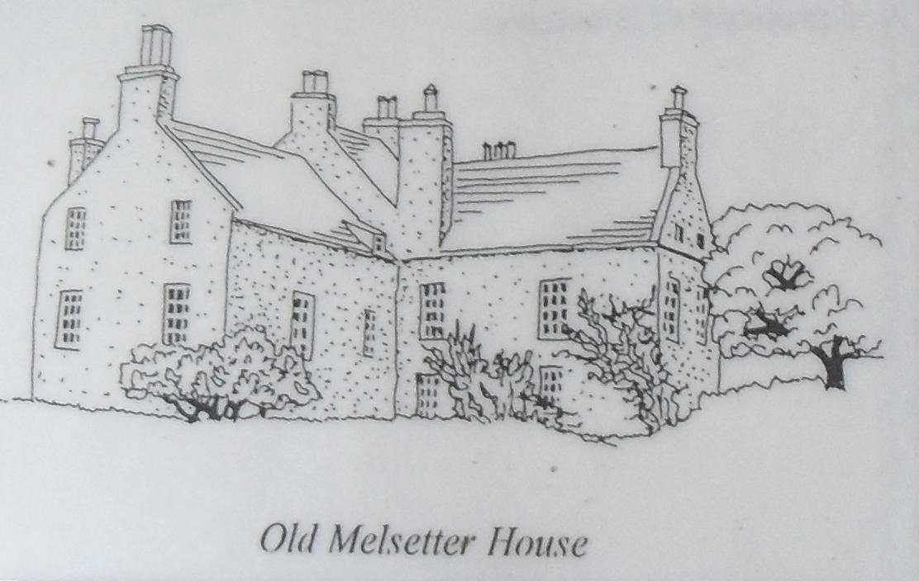
James Moodie, fourth Laird of Melsetter
1643 to 1681
James was Francis’ “eldest lawful son”. As a young man of 21 he is said to have “created an ryot” in the streets of Kirkwall having “rushed from the barr” and cleared his way from the court with a drawn sword. He appears to have settled down after his inheritance however, and devoted two decades to the rehabilitation of the Moodie estates, also acquiring a large amount of land in Walls. This process was carried on by two of his seven sons, William and James. He was a member of the Committee of Landowners appointed under Cromwell’s rule to keep order in Orkney. He died at Snelsetter in 1681.
William Moodie, fifth Laird of Melsetter
From 1681 to 1708
Before inheriting the estate, William secretly married Barbara Stewart of Burray. Both families were opposed to the union and petitioned the Bishop of Orkney to stop the marriage proclamation. The Bishop, however, took the young couple’s part and the marriage was duly confirmed. William and Barbara lived at Snelsetter where their initials were carved in a stone which can now be seen in the wall of an outbuilding at Melsetter. William was unable to pay the outstanding debts of the estate and by 1697 was bankrupt. He mortgaged the properties to his brother, Captain James Moodie, a career naval officer.
The initials of William Moodie and his wife Barbara Stewart
Captain James Moodie, sixth Laird of Melsetter
From 1708 to 1720
James, William’s eldest son, was a captain in military service and returned to Melsetter in 1697 to find it mortgaged to his uncle and namesake Captain James Moodie RN. With the aid of his uncle’s wealth, Captain Moodie increased the estate, built a mill, other farm buildings and a house at Melsetter. He enclosed parks for sheep, encouraged smuggling, ran a profitable ferry service from Walls to Caithness and supplied some of the first Orcadian recruits for the Hudson Bay Company.
He was a Jacobite, but by posing as a loyal supporter of the Hanerovian crown, James served member of Parliament for Orkney and Shetland from 1715 to 1722and was Deputy lieutenant for the County. Eventually losing his parliamentary seat and the favour of the Hanerovian Court, he fled into exile and became a colonel in the Spanish army. He never returned to Orkney.
Captain James Moodie RN, seventh Laird of Melsetter
From 1720 to 1725
In 1696 Captain Moodie, by carrying an illegal cargo of luxury goods from Turkey on board his naval vessel, acquired sufficient wealth to save the family land from creditors. He retired from a distinguished career in the navy to take over the estate from his nephew but became involved in a local feud that was to cost him his life and ruin the family. A staunch Hanerovian, his occupancy of the estate was marred by a dispute with the Jacobean family of Sir James Stewart of Burray. In October 1725 Alexander Stewart, younger brother of Sir James, was flogged by the Moodies of Melsetter for hunting wildfowl on disputed territory. Sir James was enraged by this and on October 25th of that year, whilst Captain Moodie was heading for a meeting of JPs in St Magnus Cathedral, Kirkwall, the Captain was shot and mortally wounded by one of Stewart’s servants. At the time of his death his only surviving son was an infant of two years old. Benjamin’s mother, the Captain’s second wife Christian Crawford, took over the running of the estate.
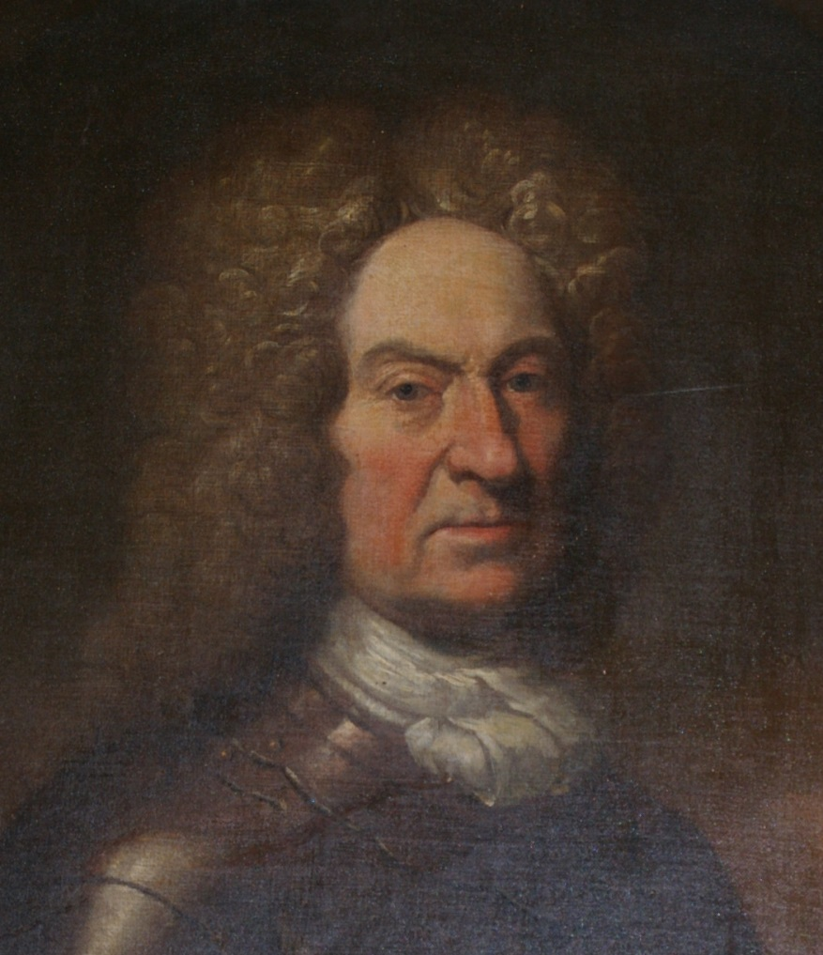
Captain James Moodie RN
Christiana Crawford, Factorix of Melsetter
From 1725 to 1744
Captain Moodie’s widow managed the estate during her son’s minority in a forthright and strong-willed manner. When a minister of Walls questioned her morals, she denounced him in his pulpit and threatened him “with four charged pistols”. In 1736, when Sir James Stewart of Burray sent a party to Walls to take possession of some property …”they were met by the Lady Melsetter… and a good many armed men with guns, swords, pistols and batons, who deforced them”. Her son, Benjamin, took over the estate in 1744.
Captain Benjamin Moodie, eighth Laird of Melsetter
From 1744 to 1769
Debts on the Melsetter Estate forced Benjamin into the army “with a view to repairing my little fortune”. During his absence the Jacobite rebels sacked Melsetter House …”in a most outrageous and barbarous manner, sparing nothing but plundering everything that was portable and destroying almost everything else.” Captain Moodie took his revenge. He was given command of a force of marines to quell the Orkney Jacobites, arrested Sir James Stewart of Burray - his father’s murderer, and sent him to the Tower of London for trial. He then proceeded to arrest the other Jacobite lairds and razed their houses. To those who pleaded with him Captain Moodie is said to have replied “whose side began the spulyie (spoiling) of houses?” A number of lairds managed to escape and went into hiding in caves on Westray named the “Gentlemen’s Ha”. Although they avoided the wrath of Captain Moodie, the Orkney weather and the desperately bleak conditions in the caves had long term effects on their health. He eventually took a wife, Henrietta Sinclair of Olrig in Caithness, who had thirteen children in as many years.
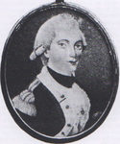
Captain Benjamin Moodie
Major James Moodie, ninth Laird of Melsetter
From 1769 to 1815
Benjamin’s eldest son inherited the semi-bankrupt estate in 1769. To reduce the debts and launch his six brothers into military careers, he served in the Orkney and Shetland and Rothesay and Caithness Fencibles. Unfortunately, landed property in Orkney had been depreciating since the turn of the century and the debts continued to accumulate. Despite his efforts, and the boom in kelp making from which other Orkney lairds prospered, he was unable to redress the balance. In 1820, greatly saddened by the demise of the estate, he died aged 77.
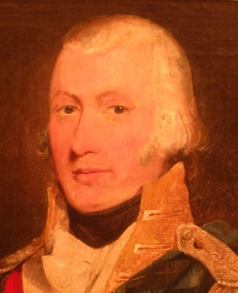
Major James Moodie
Captain Benjamin Moodie, tenth Laird of Melsetter
From 1815 to 1818
Major Moodie made the estate over to his eldest son Benjamin in 1815. After taking part in Napoleon’s defeat Benjamin returned to the bankrupt Melsetter estate and in 1818, as he could see no alternative to the sale of the property, it was sold to Major Moodie’s son in law, Robert Heddle of Cletts, South Ronaldsay. Benjamin left Orkney for the Cape of Good Hope in 1817, where he played a major role in the agricultural affairs of the Cape Province and organised an emigration scheme for Scottish labourers and craftsmen.
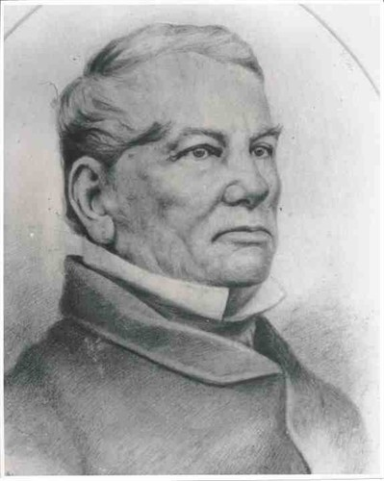
Captain Benjamin Moodie
In 1893, his son Thomas led the ‘Moodie Trek’ from what was then the Orange Free State to the eastern border of Zimbabwe and founded a settlement there which he named Melsetter.
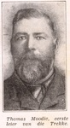
‘Big Tom’, Thomas Moodie

